Comprehensive School Improvement Plan

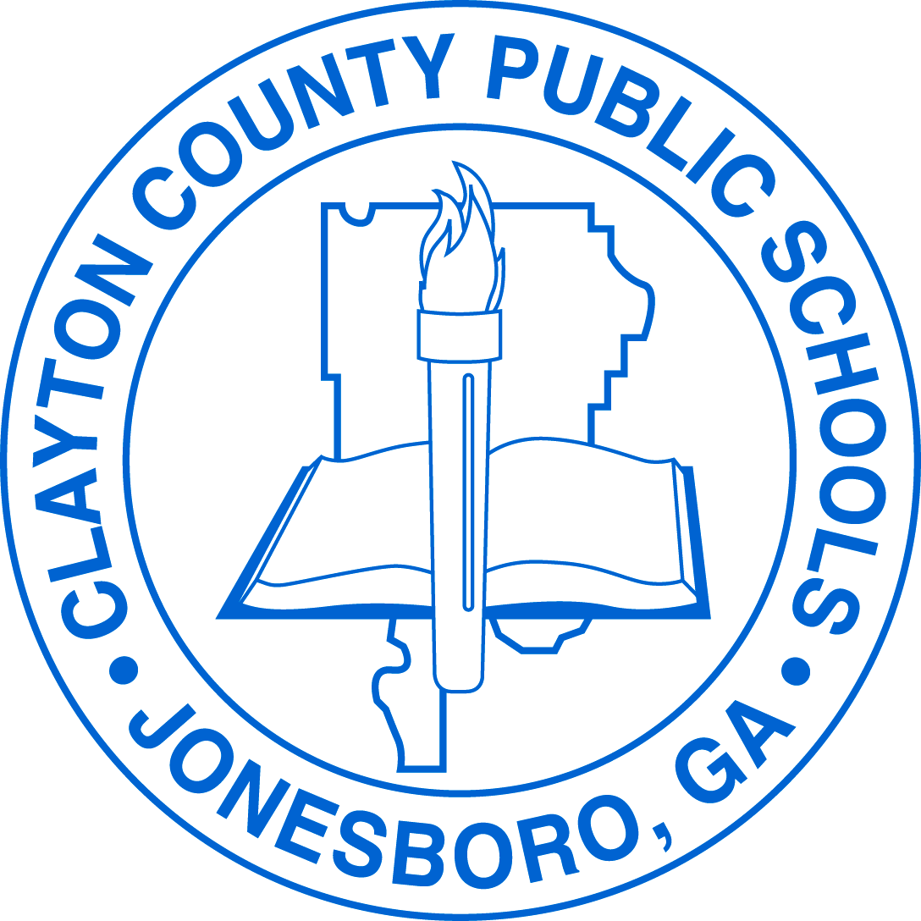

Edmonds Elementary School

2018-2019

Vision Statement
The vision of Clayton County Public Schools is to be a district of high performance ALL students
to live and compete successfully in a global society.

Mission Statement
The mission of Clayton County Public Schools is to empower students to achieve academic and personal goals.

Principal: Maurice Roberts

Assistant Principal(s): Dr. Aquannette Salter

School Leadership/Improvement Team

Name | Position
Mr. Maurice Roberts | Principal
Dr. Aquannette Salter | Assistant Principal
Ms. Angela Hutton | Site Facilitator
Ms. Deidre Odom | EIP Lead
Ms. Julia Montgomery | 5th Grade Teacher
Ms. Demetress Culler | 1st Grade Teacher
Dr. Theresa Hunter | 4th Grade Teacher
Ms. Chailoea Pelt | 3rd Grade Teacher
Ms. Michelle Isaac | 2nd Grade Teacher
Ms. Tina Goolsby | ESOL Teacher
Ms. Tasandra Washington | DES Teacher
Ms. Schkedria Williams | Counselor
Ms. Jeanne Jones | Media Specialists

CCRPI Score
2014-2015 | 2015-2016 | 2016-2017 | 2017-2018 | 2016-2020 Goals
Overall CCRPI Score: 58.1 | Overall CCRPI Score:51.1 | Overall CCRPI Score:70.8 | Overall CCRPI Score: | 2016 Goal: 70.8 2019 Goal: 81.14  2017 Goal: 73.60 2020 Goal: 85.20  2018 Goal: 77.28  Overall CCRPI Goals based on the following formula:  CCPRI Performance Goals  For each year during the five-year Strategic Waiver School System term, formerly the Investing in Educational Excellence (IE2), with the baseline year 2015-2016, ____School will increase its College and Career Ready Performance Index (CCRPI) score with Challenge Points by 3% of the gap between the baseline year CCRPI score and 100.  $$IE2 Annual Growth=\left(100-2016 CCRPI Score \left(without Challenge Points\right)\right)×0.03$$  Example  Baseline CCRPI Score Expected Annual Growth Year 1 Year 2 Year 3 Year 4 Year 5  70.8 (100 – 65)(.03) 65 + 1(1.05) 65 + 2(1.05) 65 + 3(1.05) 65 + 4(1.05) 65 + 5(1.05)  1.05 73.60 77.28 81.14 85.20 89.46
Achievement Points Earned: 19.9/50 | Achievement Points Earned: 18/50 | Achievement Points Earned: 22.250 | Content Mastery Points Earned:  /30
Progress Points Earned: 33.9/40 | Progress Points Earned: 29.3/40 | Progress Points Earned: 39.3/40 | Progress Points Earned:  /35
Achievement Gap Points Earned: 3.3/10 | Achievement Gap Points Earned: 3.3/10 | Achievement Gap Points Earned: 8.3/10 | Closing Gaps Points Earned:  /15
Challenge Points Earned: /10 | Challenge Points Earned: /10 | Challenge Points Earned: /10 | Readiness Points Earned /20

Intervention Data

DIBELS Percentage

School Year |  | BOY |  |  | MOY |  |  | EOY
2017-18 | Grade Level | Intensive | Strategic | Benchmark | Intensive | Strategic | Benchmark | Intensive | Strategic | Benchmark
 | Kindergarten | 50% | 18% | 32% | 17% | 16% | 67% | 15% | 16% | 69%
 | First | 39% | 8% | 53% | 49% | 15% | 36% | 59% | 8% | 33%
 | Second | 51% | 10% | 39% | 44% | 13% | 43% | 49% | 14% | 37%
 | Third | 52% | 7% | 41% | 50% | 11% | 39% | 44% | 13% | 43%
2018-19 | Grade Level
 | Kindergarten
 | First
 | Second
 | Third

iReady

School Year | BOY | MOY |  | EOY
2017-18
2018-19

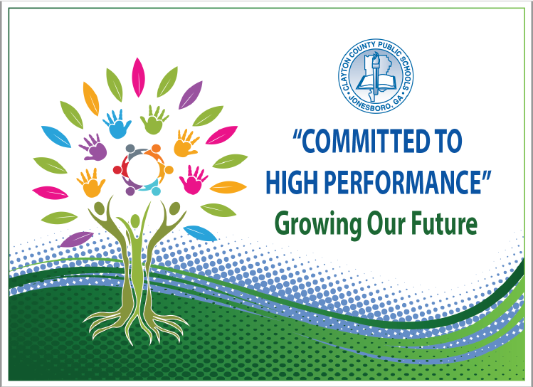
Strategic Goals
To increase academic achievement for all students in Clayton County Public Schools as evidenced by state, national, and international assessment results
To provide and maintain a safe and orderly learning environment
To create an environment that promotes active engagement, communication, accountability, and collaboration of all stakeholders to maximize student achievement
To provide high quality support services delivered on time and within budget to promote high performance in the Clayton County Public Schools
To recruit, develop, and retain highly qualified and effective staff

Action Plan

Growth Goals
Grade Level/  Subject | Baseline | Annual Grown Needed  Each Year | Points Needed for SY18-19 | SY 2018-2019 | SY 2019-2020 | SY 2020-2021 | SY 2021-2022 | SY 2022-2023
3rd ELA | 16 | 11 | 21 | 37 | 48 | 59 | 69 | 80
4th ELA | 24 | 9 | 19 | 42 | 52 | 61 | 71 | 80
5th ELA | 17 | 11 | 21 | 38 | 48 | 59 | 69 | 80
3rd Math | 34 | 8 | 15 | 49 | 57 | 65 | 72 | 80
4th Math | 37 | 7 | 14 | 52 | 59 | 66 | 73 | 80
5th Math | 10 | 12 | 23 | 33 | 45 | 57 | 68 | 80
5th Science | 13 | 11 | 22 | 35 | 46 | 58 | 69 | 80
5th Social Studies | 14 | 11 | 22 | 36 | 47 | 58 | 69 | 80

Reading & Writing Growth Goals
Grade Level/  Subject | Baseline | Annual Grown Needed Each Year | Points Needed for SY18-19 | SY 2018-2019 | SY 2019-2020 | SY 2020-2021 | SY 2021-2022 | SY 2022-2023
3rd-5th Reading | 46.32 | 8 | 16 | 63 | 71 | 79 | 87 | 95
Idea Development, Organization, and Coherence Goals
3rd Writing | 2.27 | 13 | 26 | 28 | 41 | 54 | 67 | 80
4th Writing | 15.69 | 11 | 21 | 37 | 48 | 59 | 69 | 80
5th Writing | 6.31 | 12 | 25 | 31 | 43 | 55 | 68 | 80
Language Usage and Conventions Goals
3rd Writing | 1.14 | 13 | 26 | 27 | 41 | 54 | 67 | 80
4th Writing | 8.82 | 12 | 24 | 33 | 44 | 56 | 68 | 80
5th Writing | 6.32 | 12 | 25 | 31 | 43 | 55 | 68 | 80
Narrative Writing Response Goals
3rd Writing | 2.27 | 13 | 26 | 28 | 41 | 54 | 67 | 80
4th Writing | 9.80 | 12 | 23 | 33 | 45 | 57 | 68 | 80
5th Writing | 6.32 | 12 | 25 | 31 | 43 | 55 | 68 | 80

Performance Objective 1: By 2023, Clayton County Public Schools will increase the percentage of student scoring at the Proficient and/or Distinguished levels on the Georgia Milestones to at least 80% in each content area.
GADOE School Improvement Systems: Coherent Instruction, Effective Leadership, Family and Community Engagement, Professional Capacity
Action Steps/ Tasks | Timeline | Project Leader(s) and School Level Person(s) Monitoring | Resources/ Funding | Check Points/ Related Artifacts and Evidence | Professional Learning  Activity and Date  (where applicable)
All students will demonstrate their understanding of a text (e.g. selection, illustration, graph,, etc.) through the use of a Close-Reading Protocol. | Aug. 2018  -  May 2019 | Administration  Instructional Site-Facilitator | Title I Funding  School Accounts | Check Points  Monthly half day collaborative planning (analyzing student work protocol)  Observations (formal,informal)  Progress Monitoring (DIBELS Next & iReady)  Related Artifacts and Evidence  Weekly Assessments (Evidence Based Writing)  Writing of the Month  Student Journals  Classroom Observations  Lesson Plan Analysis  K-2 Classroom Observations (Integration)  iReady Assessments Results & Usage | Close Reading PD August 15, 2018  Analyzing Student Work 9/12 Protocol September 7, 9/ 14 ,21  Rigor Relevance PD 7, 9, 14,21  DOK October- 5  Academic Discussions November 2,9,16
Implement Rigor, Relevance Framework  Evidenced based Writing--August September  Higher order Questioning  October Academic Discussions -november, December | September 2018  May 2019 | Administration  Instructional Site-Facilitator | Title I Funding  School Accounts | Check Points  Weekly Collaborative Planning  Related Artifact/Evidence  Deconstructing Standards Document  Intentional Classroom Observations  Student Work Samples with Standards Based Rubrics  Lesson Plans with Higher Order Thinking Questions | Unpacking Standards September 12  Analyzing Student Work Protocol September 7, 9/ 14 ,21  Rigor Relevance PD 7, 9, 14,21  DOK October- 5  Academic Discussions November 2,9,16

Supplemental Supports: What supplemental action steps will be implemented for these subgroups?
Economically Disadvantaged | Foster and Homeless
Co- Teaching Model (Parallel Teaching)
Vocabulary
English Learners | Migrant
Co- Teaching Model (Team Teaching)
WIDA standards, Vocabulary
Race/Ethnicity/Minority | Students with Disabilities
 | Co- Teaching Model (Team Teaching)

Performance Objective 2: Over the next five years, Clayton County Public Schools will increase the graduation rate from 69.6% to 90% or higher.
GADOE School Improvement Systems: Coherent Instruction, Effective Leadership, Family and Community Engagement, Professional Capacity
Action Steps/ Tasks | Timeline | Project Leader(s) and School Level Person(s) Monitoring | Resources/ Funding | Check Points/ Related Artifacts and Evidence | Professional Learning  Activity and Date  (where applicable)
Implement Rigor, Relevance Framework  Evidenced based Writing--August September  Higher order Questioning  October Academic Discussions -november, December |  | Administration | General | Check Points  Monthly half day collaborative planning (analyzing student work protocol)  Observations (formal,informal)  Progress Monitoring (DIBELS Next & iReady)  Related Artifacts and Evidence  Weekly Assessments (Evidence Based Writing)  Writing of the Month  Student Journals  Classroom Observations  Lesson Plan Analysis  K-2 Classroom Observations (Integration)  iReady Assessments Results & Usage | Indistar videos GADOE training videos  See Poverty Be the Difference
All students will demonstrate their understanding of a text (e.g. selection, illustration, graph,, etc.) through the use of a Close-Reading Protocol. |  | Administration | General | Check Points  Weekly Collaborative Planning  Related Artifact/Evidence  Deconstructing Standards Document  Intentional Classroom Observations  Student Work Samples with Standards Based Rubrics  Lesson Plans with Higher Order Thinking Questions | Unpacking Standards September  EduTrax August GLM’s  Differentiated Instruction January 11,18, 25  Formal and Informal Assessments February 8, 15, 22

Supplemental Supports: What supplemental action steps will be implemented for these subgroups?
Economically Disadvantaged | Foster and Homeless
Co- Teaching Model (Parallel Teaching)
Vocabulary
English Learners | Migrant
Co- Teaching Model (Team Teaching)
WIDA standards, Vocabulary

Race/Ethnicity/Minority | Students with Disabilities
 | Co- Teaching Model (Team Teaching)

Performance Objective 3: By 2023, Clayton County Public Schools will increase the number of students absent less than 10% of their enrolled academic year.
GADOE School Improvement Systems: Effective Leadership, Supportive Learning Environment, Family and Community Engagement, Professional Capacity
Action Steps/ Tasks | Timeline | Project Leader(s) and School Level Person(s) Monitoring | Resources/ Funding | Check Points/ Related Artifacts and Evidence | Professional Learning  Activity and Date  (where applicable)
Partner with the district and community to identify support for families at-home supports that promote academic success | September- May | Administrative team | General | List of external/internal supports, Parent Center  September 28, December 18, March 17, May 8
Ensure all internal and external stakeholders are involved in the creation of school plans and initiatives | September- may | Administrative team | General | Agendas, local school council minutes, PTO agendas, leadership team minutes, | Local School council training  Parent workshops
Weekly attendance

Supplemental Supports: What supplemental action steps will be implemented for these subgroups?
Economically Disadvantaged | Foster and Homeless
English Learners | Migrant
Race/Ethnicity/Minority | Students with Disabilities

Performance Objective 4: By 2023, Clayton County Public Schools will decrease the number of discipline infractions while increasing employee morale and community support.
GADOE School Improvement Systems: Effective Leadership, Supportive Learning Environment, Family and Community Engagement, Professional Capacity
Action Steps/ Tasks | Timeline | Project Leader(s) and School Level Person(s) Monitoring | Resources/ Funding | Check Points/ Related Artifacts and Evidence | Professional Learning  Activity and Date  (where applicable)
Build consensus around the school’s processes and procedures for discipline  Decrease the amount of time the administrative team deal with discipline challenges. | September- May | Assistant Principal  Teachers  Social Worker  Behavior Specialist | General, PL,Title | School wide discipline plan  Discipline meeting agenda, minutes  Standard operating procedures posted  Review school wide discipline weekly  Review school wide discipline plan and data monthly with staff | August - May
Provide ongoing professional development to staff about the multi-tiered system of support and interventions for academics and discipline. |  | Assistant Principal  Teachers  Social Worker  Behavior Specialist |  | monthly discipline report  classroom behavior intervention logs  PD agendas  committee minutes | August -May

Supplemental Supports: What supplemental action steps will be implemented for these subgroups?
Economically Disadvantaged | Foster and Homeless
English Learners | Migrant
Race/Ethnicity/Minority | Students with Disabilities

